**OKC Breeders Directory** **2021**

**Ahalapas Blueblood Bulldog** 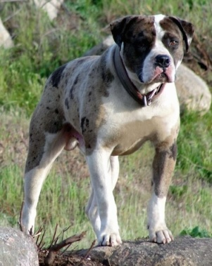

Dave and Joanne Swift, Osgoode, ON

**Kennel:** Knighterrant Mastiffs

www.knighterrantmastiffs.com

## Alaskan Malamute\_\_\_\_\_\_\_\_\_\_\_\_\_\_\_\_\_\_\_\_ IMG_0923.jpg

Samurdhi Gunawardena, Kemptville, ON

**Kennel:** NorthernSong

NorthernSongMalamutes.ca

**Australian Shepherd** 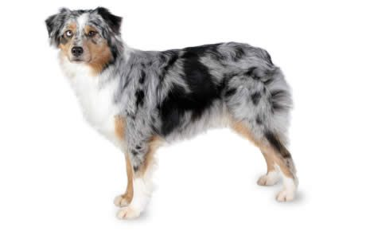

Beverly Hurst, Vankleek Hill, ON 613-678-2553

**Kennel**: Lein Reg'd

[www.k9101.ca](http://www.k9101.ca)

**Bearded Collies** 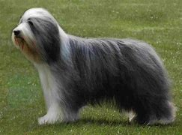

Terri & Sarah Duff, Johnstown, 613-691-7617

**Kennel:** Baileysong Irish Wolfhounds Sassway Beardies

[www.baileysong.com](http://www.baileysong.com)

**Bichon Frise** [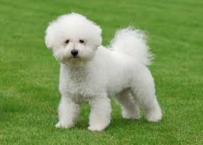](https://www.google.ca/imgres?imgurl=https://bowwowinsurance.com.au/wp-content/uploads/2014/12/bichon-frise-adult-standing-on-lawn.jpg&imgrefurl=https://bowwowinsurance.com.au/dogs/dogs-breeds/bichon-frise/&docid=wyvvBr8KAreQkM&tbnid=969gwaOXphOT6M:&vet=10ahUKEwjd7sPYt-LYAhVs2IMKHT2XC7UQMwiPAigVMBU..i&w=800&h=572&bih=791&biw=1680&q=Bison%20frise&ved=0ahUKEwjd7sPYt-LYAhVs2IMKHT2XC7UQMwiPAigVMBU&iact=mrc&uact=8)

Sue and Ivan Fenton, Gloucester, ON, 613-745-2802

**Kennel:** Suvan Kennels Perm Reg'd

[www.suvanbichons.com](http://www.suvanbichons.com)

**Borzoi** 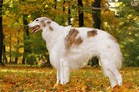

Paul Allard and Steve Pedro, Winchester 613-319-3744

**Kennel:** Freckashpeng

[www.freckashpeng.com](http://www.freckashpeng.com)

**Cairn Terrier** [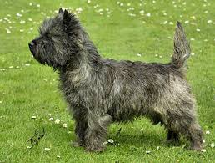](https://www.google.ca/imgres?imgurl=http://elite-pets.narod.ru/dog/47.jpg&imgrefurl=http://elite-pets.narod.ru/dogs_br47.htm&docid=prxSn24dgL8bgM&tbnid=LmisoNFxrgz8tM:&vet=10ahUKEwiU-buNueLYAhVhzIMKHa0uAW44ZBAzCCEoHzAf..i&w=400&h=303&bih=791&biw=1680&ved=0ahUKEwiU-buNueLYAhVhzIMKHa0uAW44ZBAzCCEoHzAf&iact=mrc&uact=8)

Doreen Linkletter, Almonte, ON, 613-256-2594

**Kennel**: Dorlin (Perm) Reg'd

[www.cairnterriers.ca](http://www.cairnterriers.ca)

**Cavalier King Charles Spaniel**  [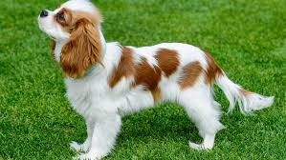](https://www.google.ca/imgres?imgurl=http://www.canalvie.com/polopoly_fs/1.1802941.1467755392!/image/chien-cavalier-king-charles.jpg_gen/derivatives/cvlandscape_670_377/chien-cavalier-king-charles.jpg&imgrefurl=http://www.canalvie.com/famille/animaux/race-chien-cavalier-king-charles-1.1767633&docid=ajqgAhsRY9-z9M&tbnid=NfdMgxbT6zOFlM:&vet=10ahUKEwiEoe2fuuLYAhUGxYMKHTKKBaQQMwiBAigzMDM..i&w=670&h=377&bih=791&biw=1680&q=cavalier%20king%20charles&ved=0ahUKEwiEoe2fuuLYAhUGxYMKHTKKBaQQMwiBAigzMDM&iact=mrc&uact=8)

Donna Robillard, Greely, ON, 613-821-1247

**Kennel**: Winrob (Reg'd)

[winrob@magma.ca](mailto:winrob@magma.ca)

**Dandie Dinmount Terrier** [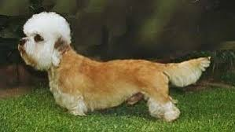](https://www.google.ca/imgres?imgurl=https://www.dogbreedinfo.com/images/DandieDinmontTerrier21.jpg&imgrefurl=https://www.dogbreedinfo.com/dandiedinmont.htm&docid=JlUNAel_hfxG1M&tbnid=2t-vkTMEIsllgM:&vet=10ahUKEwj6l_-nvuLYAhUj2IMKHabuAkI4ZBAzCA8oDTAN..i&w=300&h=169&bih=791&biw=1680&q=dandie%20dinmont%20terrier%20canada&ved=0ahUKEwj6l_-nvuLYAhUj2IMKHabuAkI4ZBAzCA8oDTAN&iact=mrc&uact=8)

Linda Bergh, Ottawa, ON, 613-724-2662

**Kennel**: Horizons (Perm Reg'd)

[lindabergh21@hotmail.com](mailto:lindabergh21@hotmail.com)

**English Mastiff 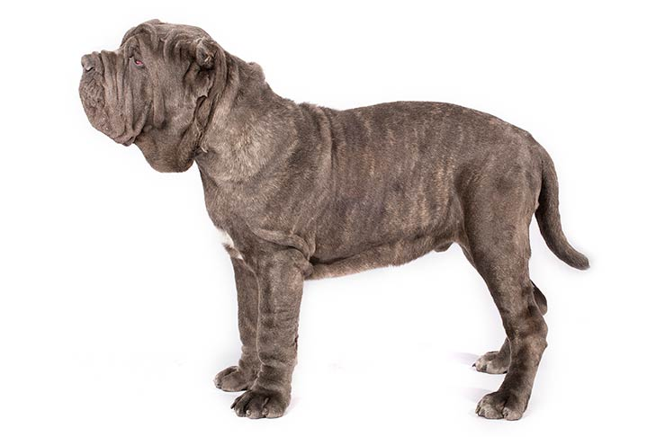**

Dave & Joanne Swift, Osgoode, ON 613-821-6279

**Kennel:**  Knighterrant Mastiffs

[www.knighterrantmastiffs.com](http://www.knighterrantmastiffs.com)

**English Setter** 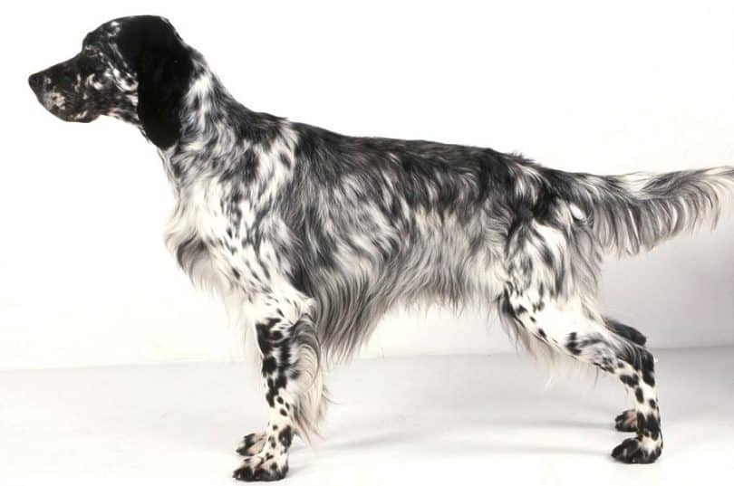

Oxana Erokhovets/Oleg Khmourovitch, Kemptville 613-859-6937

**Kennel:**  Broughall

[www.broughallenglishsetters.com](http://www.broughallenglishsetters.com)

**Field Spaniel\_\_\_\_\_\_\_\_\_\_\_\_\_\_\_\_\_\_\_\_\_\_\_\_\_\_\_\_\_\_** 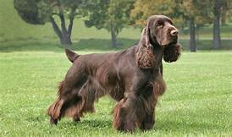

Rebecca Menard,

**Kennel:** Pemberley Fields

[Pemberleyfields@gmail.com](mailto:Pemberleyfields@gmail.com)

**French Bulldog** [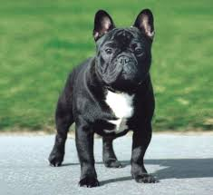](https://www.google.com/imgres?imgurl=http://1.bp.blogspot.com/-zZTAOhz2llQ/UyXOxTlKmvI/AAAAAAAACMs/HUOagjA5YiM/s1600/french+bulldog+from+DHG+report+2013.png&imgrefurl=http://pedigreedogsexposed.blogspot.com/2014/03/french-bulldogs-enviable-life.html&docid=YgHn3Em9i9lGuM&tbnid=vz3gkYN_Q4KeUM:&vet=10ahUKEwj-t9zxv-LYAhXC5oMKHdCaAtw4ZBAzCBwoGjAa..i&w=1434&h=1314&bih=791&biw=1680&q=french%20bull%20dog&ved=0ahUKEwj-t9zxv-LYAhXC5oMKHdCaAtw4ZBAzCBwoGjAa&iact=mrc&uact=8)

Heidi Merkli, Carp, ON 613-839-2156

**Kennel**: Bugaboo (Reg'd)

[www.bugaboodogs.ca](http://www.bugaboodogs.ca)

**German Shepherd** [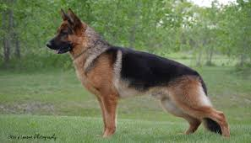](https://www.google.com/imgres?imgurl=http://westsidekennels.ca/wp-content/uploads/2017/08/banner3.jpg&imgrefurl=http://westsidekennels.ca/&docid=GvdOxNJR9tFxsM&tbnid=BIuhP7R6eCJo7M:&vet=10ahUKEwjRspmfweLYAhXs44MKHZ_cAlg4ZBAzCAYoAzAD..i&w=1750&h=1000&bih=791&biw=1680&ved=0ahUKEwjRspmfweLYAhXs44MKHZ_cAlg4ZBAzCAYoAzAD&iact=mrc&uact=8)

Hartley & Darlene Smith, Almonte, ON

613-256-1570

**Kennel**: Shebland Perm Reg'd

[www.sheblandgsds.com](http://www.sheblandgsds.com)

**German Shorthaired Pointer** 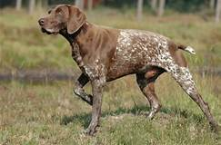

Denise Cranna, Kanata, 403-877-7150

**Kennel:** Grassridge

[grassridgekennel@gmail.com](mailto:grassridgekennel@gmail.com)

**German Wirehaired Pointer** [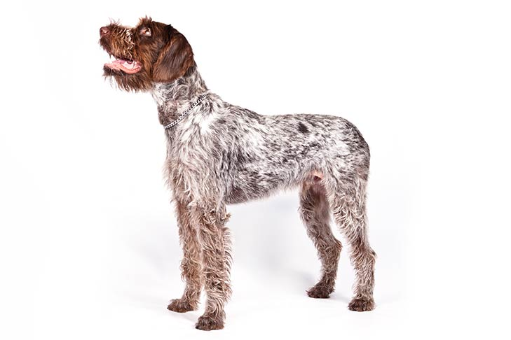](https://www.google.com/url?sa=i&rct=j&q=&esrc=s&source=images&cd=&cad=rja&uact=8&ved=2ahUKEwjXvsDagJHhAhWIxYMKHXRvBtEQjRx6BAgBEAU&url=https://www.akc.org/dog-breeds/german-wirehaired-pointer/&psig=AOvVaw0LWGB94-MSTv4M_yq4Y21t&ust=1553181089336875)

Wendy McKay, Woodlawn, ON

613-832-3223

**Kennel:** Follyhill (perm) Reg'd

Consulting Only, no longer breeding

**Golden Retriever\_\_\_\_\_\_\_\_\_\_\_\_\_\_\_\_\_\_\_\_\_\_\_\_\_\_\_** [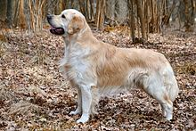](https://en.wikipedia.org/wiki/File:Golden_Retriever_Carlos_(10581910556).jpg)

Anne Bendig, Perth, ON

613-264-9699

**Kennel:**  Taygold

www.taygoldregistered.com

Jim & Judy Stewart, Perth, ON

613-264-0203

**Kennel:** Blueheron

www.blueherongoldens.com

**Havanese** [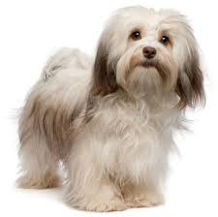](https://www.google.com/imgres?imgurl=http://www.allsmalldogbreeds.com/breeds/havanese.jpg&imgrefurl=http://www.allsmalldogbreeds.com/havanese.html&docid=0UL-TuUP6pMhkM&tbnid=v5S2QOBAEF74yM:&vet=10ahUKEwjsyp209vHYAhWL64MKHdz_A9AQMwiXAihhMGE..i&w=414&h=412&bih=791&biw=1680&q=havanese%20dogs&ved=0ahUKEwjsyp209vHYAhWL64MKHdz_A9AQMwiXAihhMGE&iact=mrc&uact=8)

Elizabeth Obrecht, Wakefield, QC, 819-459-3238

**Kennel**: Rockhurst Reg'd

www.rockhurst.ca

**Irish Setters**  [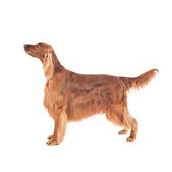](https://www.google.com/imgres?imgurl=https://www.purina.com/sites/g/files/auxxlc196/files/SPORTING_Irish-Setter.jpg&imgrefurl=https://www.purina.com/dogs/dog-breeds/irish-setter&docid=rPi1pjofUxpxWM&tbnid=2nHDK5PcFayeKM:&vet=10ahUKEwiayaGbv_PYAhWkhOAKHdNJDi8QMwi1AigyMDI..i&w=599&h=599&bih=791&biw=1680&q=irish%20setters%20dogs&ved=0ahUKEwiayaGbv_PYAhWkhOAKHdNJDi8QMwi1AigyMDI&iact=mrc&uact=8)

Joan Colburn, Nepean, ON, 613-591-6228

Available for Consultation Only

**Irish Wolfhound** [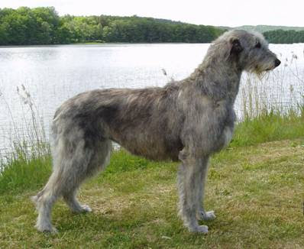](http://www.google.com/url?sa=i&rct=j&q=&esrc=s&source=images&cd=&cad=rja&uact=8&ved=0ahUKEwiKoJyU-fHYAhVm8IMKHTHjAxMQjRwIBw&url=http://www.chickensmoothie.com/Forum/viewtopic.php?f=85&t=2716062&p=87313405&psig=AOvVaw12B6i2LDAIzP5MRdDlIUuc&ust=1516929486905309)

Barbara Daley, Chelsea, QC, 819-827-1027

**Kennel**: Aotearoa Perm. Reg'd 1970

[www.aotearoaiws.net](http://www.aotearoaiws.net)

Terri & Sarah Duff, Johnstown, ON 613-691-7617

**Kennel:** Baileysong Irish Wolfhounds Sassway Beardies

[www.baileysong.com](http://www.baileysong.com)

**Italian Greyhound** [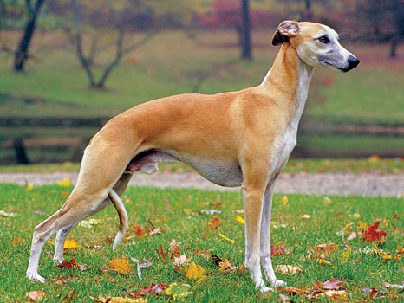](https://www.google.com/url?sa=i&rct=j&q=&esrc=s&source=images&cd=&cad=rja&uact=8&ved=0ahUKEwjFttro-vHYAhWD5YMKHTyhBVsQjRwIBw&url=https://moderndogmagazine.com/articles/whats-difference-between-italian-greyhound-and-whippet/44977&psig=AOvVaw2YnyPHy3lAvOVkvEH9e6RB&ust=1516929685777223)

Corinna Yannoulopoulos, Richmond, ON 613-838-3674

**Kennel**: Riverport Kennels Reg'd

www.pickofthelitter.org

**Japanese Chin** [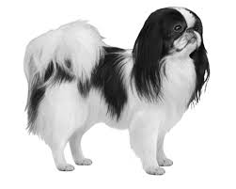](https://www.google.com/imgres?imgurl=https://images.ctfassets.net/w00x6p5qkejz/1AQ9MyAy6E6q2uyU8ImI2m/2201c40682dafcb56909234bcddf5623/Japanese_Chin_B_W_Small_File.png&imgrefurl=https://www.wisdompanel.com/explore-breed/breed-details/japanese-chin/&docid=qME_uCXgxV12xM&tbnid=MnQrCDu1M54QVM:&vet=10ahUKEwjDo46b5OraAhWHyoMKHeBnDS4QMwicAShhMGE..i&w=450&h=360&bih=791&biw=1680&q=japanese%20chin&ved=0ahUKEwjDo46b5OraAhWHyoMKHeBnDS4QMwicAShhMGE&iact=mrc&uact=8)

Tracy Hart and Lloyd Howley, Kars, ON 613-725-4518

**Kennel:** Chiyoko Perm Reg'd

www.chiyokochin.com

**Labrador Retrievers** [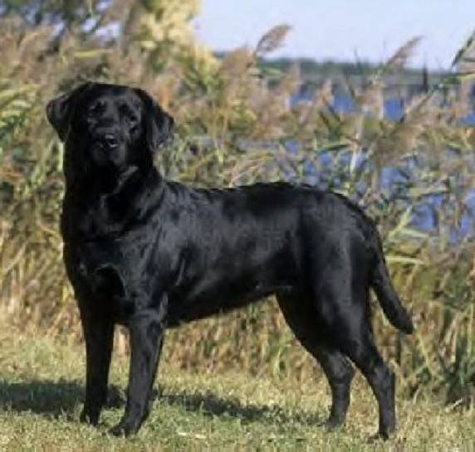](http://www.google.com/url?sa=i&rct=j&q=&esrc=s&source=images&cd=&cad=rja&uact=8&ved=0ahUKEwjh_MH7_PHYAhUrzoMKHRPgBrYQjRwIBw&url=http://nicolebasaraba.com/labrador-retrievers-theyre-canadian/&psig=AOvVaw0wgcO0y1uupSwzIhicudVu&ust=1516930137605535)

Leslie Grant, North Gower, ON 613-258-4856

**Kennel**: Gorsebrook Perm Reg'd

[www.gorsebrook.com](http://www.gorsebrook.com) or .net

Mary-Anne & Geoff Lauzon, Russell, ON 613-445-3047

**Kennel**: Kriscoland Labradors Perm Reg'd

www.kriscoland.com

Lynda Judd, Kanata, ON 613-862-3126

**Kennel**: Mooselake Labradors

www.mooselakelabs.com

**Miniature Schnauzers \_\_\_\_\_\_\_\_\_** 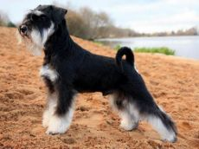

Louise Beggs, Stittsville, ON 613-852-4469

**Kennel:**  Regency XCL

[louisebeggs@icloud.com](mailto:louisebeggs@icloud.com)

Pat Parent, Jasper, 613-283-5458

**Kennel:**  Greysatin Kennels Reg’d

Greysatinkennels.com

**Newfoundland\_\_\_\_\_\_\_\_\_\_\_\_\_\_\_\_\_\_\_\_\_\_\_\_\_\_\_\_** [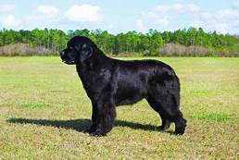](https://ca.images.search.yahoo.com/images/view;_ylt=AwrJ5sylys5eIE8AkpA.7olQ;_ylu=X3oDMTI0ZW9hZ2kyBHNlYwNzcgRzbGsDaW1nBG9pZANiMGQyOTgyMWVjYjA0MWIwZDcwODk3MTBjYmRmZTQzMQRncG9zAzI2MQRpdANiaW5n?back=https://ca.images.search.yahoo.com/yhs/search?p=newfoundland+dog&fr=yhs-rogers-rogers_001-s&hsimp=yhs-rogers_001&hspart=rogers&nost=1&tab=organic&ri=261&w=355&h=238&imgurl=d17fnq9dkz9hgj.cloudfront.net/breed-uploads/2018/08/newfoundland-dog-detail.jpg?bust=1535566140&width=355&rurl=https://www.petfinder.com/dog-breeds/newfoundland/&size=22.1KB&name=Newfoundland+Dog+Dog+Breed+Profile+|+Petfinder&p=newfoundland+dog&oid=b0d29821ecb041b0d7089710cbdfe431&fr2=&fr=yhs-rogers-rogers_001-s&tt=Newfoundland+Dog+Dog+Breed+Profile+|+Petfinder&b=241&ni=192&no=261&ts=&tab=organic&sigr=11ijqmto4&sigb=14o0u94f9&sigi=139khcdg6&sigt=11ecv4p38&sign=11ecv4p38&.crumb=KFkL1UQhZn1&fr=yhs-rogers-rogers_001-s&hsimp=yhs-rogers_001&hspart=rogers)

Pat LeClair, Elginburg, ON 613-392-2761

**Kennel:** Beardog

<http://patspuppz.weebly.com>

**Nova Scotia Duck Toller Retriever**  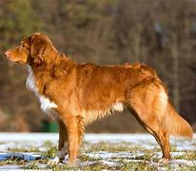

Dawn O’Leary, Stittsville, 613-831-9961

**Kennel:** Dragonluck Kennels

www.dragonluck.ca

**Pekingese** [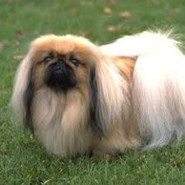](https://www.google.com/imgres?imgurl=https://s-media-cache-ak0.pinimg.com/236x/7d/ce/75/7dce7532cdad1e3c0c276dabf7718efe--pekingese-dogs-dog-names.jpg&imgrefurl=https://www.pinterest.com/pin/12103492731029216/&docid=592SwoEdavKf8M&tbnid=EkmRgXUnEsflKM:&vet=10ahUKEwiWr6e1hvLYAhUDbKwKHXePAO442AQQMwgqKCcwJw..i&w=234&h=234&itg=1&bih=791&biw=1680&q=pekingese%20dogs&ved=0ahUKEwiWr6e1hvLYAhUDbKwKHXePAO442AQQMwgqKCcwJw&iact=mrc&uact=8)

Benjamin Chin & Michael Guy,

Brockville, ON 613-302-3198

**Kennel**: Leahcim Kennels Reg'd

[www.LeahcimKennels.ca](http://www.LeahcimKennels.ca)

**Pomeranian\_\_\_\_\_\_\_\_\_\_\_\_\_\_\_\_\_\_\_\_\_\_\_\_\_\_\_\_\_\_\_**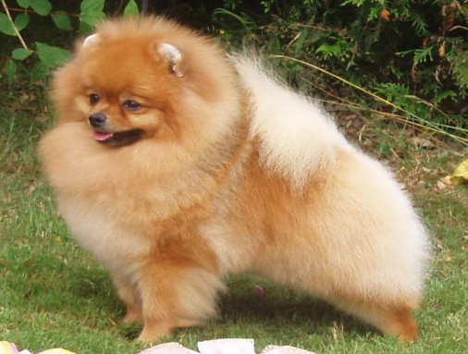

Lana-Lee Smith, Ottawa, ON 613-608-3468

**Kennel:** Lion Dor Poms

liondorpomereanians@hotmail.com

**Pugs** 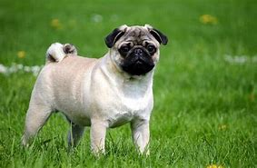

Heidi Merkli, Carp, 613-839-2156

**Kennel :** Bugaboo Reg’d

[www.bugaboodogs.ca](http://www.bugaboodogs.ca)

**Shiba Inu** [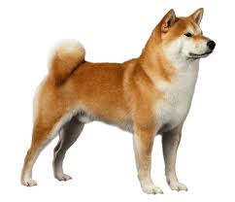](https://www.google.com/imgres?imgurl=https://images.wagwalkingweb.com/media/breed/shiba-inu/appearance/shiba-inu.png?auto=compress&fit=max&imgrefurl=https://wagwalking.com/breed/shiba-inu&docid=7ZADAYWnHqp0nM&tbnid=3tBwfN-Lil36eM:&vet=10ahUKEwj3vLCcifLYAhVC7qwKHTUfChEQMwjXASgUMBQ..i&w=567&h=489&bih=791&biw=1680&q=shiba%20inu&ved=0ahUKEwj3vLCcifLYAhVC7qwKHTUfChEQMwjXASgUMBQ&iact=mrc&uact=8)

Carol Broadhurst & Mike Pinfold,

Kemptville, ON 613-258-5990

**Kennel**: Kortar Perm Reg'd

www.kortar.ca

**Siberian Husky** [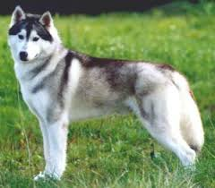](https://www.google.com/imgres?imgurl=http://www.expodog.com/enciclopedia/foto/15.jpg&imgrefurl=http://www.expodog.com/enciclopedia/siberian-husky-15&docid=j_ZyOcIo_wLB5M&tbnid=R9VHTEZ09EmzpM:&vet=10ahUKEwjc48H-ivLYAhVPS60KHYLYCBs4vAUQMwgTKBAwEA..i&w=300&h=263&bih=791&biw=1680&q=siberian%20husky&ved=0ahUKEwjc48H-ivLYAhVPS60KHYLYCBs4vAUQMwgTKBAwEA&iact=mrc&uact=8)

Carol Broadhurst & Mike Pinfold,

Kemptville, ON 613-258-5990

**Kennel**: Kortar Perm Reg'd

www.kortar.ca

**Werimaraner** [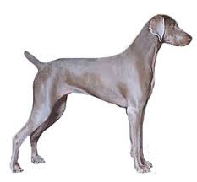](https://www.google.com/imgres?imgurl=http://www.dogencyclopedia.org/weimaraner-short-hair.jpg&imgrefurl=http://www.utdforum.com/forum/showthread.php?t=211095&docid=vNA1Hl6Poix0bM&tbnid=OfBm8-Ir3s1i5M:&vet=10ahUKEwjg_K2VufPYAhUImuAKHduPCb04rAIQMwgKKAgwCA..i&w=280&h=259&bih=791&biw=1680&q=weimaraner%20dog&ved=0ahUKEwjg_K2VufPYAhUImuAKHduPCb04rAIQMwgKKAgwCA&iact=mrc&uact=8)

Wendy McKay, Woodlawn, On 613-832-2332

**Kennel**: Follyhill (Perm) Reg'd

Consulting Only, no longer breeding

**West Highland White Terrier** [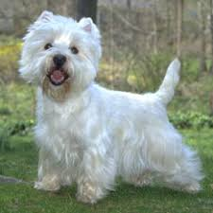](https://www.google.com/imgres?imgurl=https://s-media-cache-ak0.pinimg.com/originals/a1/61/b8/a161b8ccb0aec86a091fd9b583a014db.jpg&imgrefurl=https://www.pinterest.com/pin/363947213618285401/&docid=1AcJziP7-7gEiM&tbnid=tGD5ap9peRCqcM:&vet=10ahUKEwjrtqnxufPYAhXGmuAKHfB3BPk4rAIQMwglKCMwIw..i&w=234&h=234&bih=791&biw=1680&q=west%20highland%20white%20terrier%20dog&ved=0ahUKEwjrtqnxufPYAhXGmuAKHfB3BPk4rAIQMwglKCMwIw&iact=mrc&uact=8)

Joy Picozzi, Ottawa, On 613-838-2079

**Kennel**: UptonDean Kennels Reg'd

**Whippet** 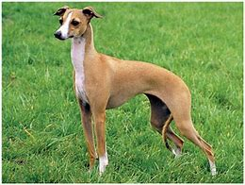

Paul Allard & Steve Pedro. Winchester, 613-319-3744

**Kennel:** Freckashpeng

www.freckashpeng.com